**Project team #9 - School Course Schedule**

**Team Members: Cameron Behdani**

**Narahari Battala**

**Ryan Scolaro**

## ***PROJECT PROPOSAL***

**Content, Scope and Objectives**

Our project plan is to use a database to recreate a UNCC-esque college course catalogue, where administrators can log in and create or delete courses. Students can then login and register for those courses, as well as viewing and deleting the courses they have registered for on their course schedule. The administrators should then be able to view the students that have registered for each course.

## ***PROJECT ENVIRONMENT***

Our project environment will mimic the environment we use for classroom activities. We will be using a MySQL server on Cloud9 for our database. Our DBMS will be phpMyAdmin. We do not plan on implementing a UI application for our database, but instead intend to rely on phpMyAdmin to display our data and functionality.

## ***HIGH LEVEL REQUIREMENTS***

### **Initial user roles**

|  |  |
| --- | --- |
| **User Role** | **Description** |
| Admin | Responsible for adding, updating, and deleting courses and departments. Can also view and edit teacher and student information. |
| Teacher | Able to see which and how many students have enrolled in their class. |
| Student | Able to register or drop courses. Also able to see which courses they have already enrolled in. |

### **Initial user story descriptions**

|  |  |
| --- | --- |
| **Story ID** | **Story description** |
| US1 | As an admin, I want to add a new department so that new courses can be added in that department. |
| US2 | As an admin, I want to add a new course so that students can enroll into the newly added course. |
| US3 | As a student I want to enroll in classes so that I can attend them. |
| US4 | As a student I want to drop the courses which I enrolled in so that I can enroll for another class. |
| US5 | As a student I want to view my enrolled courses so that I can design my schedule. |
| US6 | As an admin, I want to edit a student’s information so they can be added to/removed from a course. |
| US7 | As an admin, I want to update a department so that a department can properly reflect the courses it contains. |
| US8 | As an admin, I want to delete a department if it no longer exists. |
| US9 | As an admin, I want to update a course so that students can see any changes made to an academic course. |
| US10 | As an admin, I want to delete a course so that students can not enroll or attend a non-existent course. |
| US11 | As teacher, I want to view my courses so that I can see what students I am teaching. |
| US12 | As an admin, I want to edit a teacher’s information to reflect the courses they are teaching. |
| US13 | As a student, I want to search for a course so that I can find the course I wish to take. |

## ***HIGH LEVEL CONCEPTUAL DESIGN***

Entities:

Admin

Teacher

Student

Department

Course

Relationships:

Department contains course

Course has teacher

Student enrolls in course

Student drops course

Admin creates department

Admin creates course

Admin removes department

Admin removes course

Course has student

Admin edits department

Admin edits course

**Sprint 1**

## ***REQUIREMENTS***

List your updated user stories in decreasing order of priority and highlight the stories chosen for Sprint 1. *There is no need to explicitly show your story refinement process.* Use the format shown below.

|  |  |
| --- | --- |
| **Story ID** | **Story description** |
| US1 | As an admin/teacher/student I want to register/login a new account so that I can have access to all features. |
| US2 | As an admin, I want to add a new department so that new courses can be added in that department. |
| US3 | As an admin, I want to add a new course so that students can enroll into the newly added course. |
| US4 | As a student I want to enroll in classes so that I can attend them. |
| US5 | As a student I want to drop the courses which I enrolled in so that I can enroll for another class. |
| US6 | As a student I want to view my enrolled courses so that I can design my schedule. |
| US7 | As an admin, I want to edit a student’s information so they can be added to/removed from a course. |
| US8 | As an admin, I want to update a department so that a department can properly reflect the courses it contains. |
| US9 | As an admin, I want to delete a department if it no longer exists. |
| US10 | As an admin, I want to update a course so that students can see any changes made to an academic course. |
| US11 | As an admin, I want to delete a course so that students can not enroll or attend a non-existent course. |
| US12 | As an Admin, I want to manage the schedule of Teachers so that no conflict occurs while assigning the teacher to a section. |
| US13 | As an admin, I want to edit a teacher’s information to reflect the courses they are teaching. |
| US14 | As a student, I want to manage my schedule so that no 2 courses will be at same time. |

Refined Stories:

|  |  |
| --- | --- |
| US1 | As an admin I want to register/login a new account so that I can have access to all features.  Details: This story will need a table to hold username and password information as well as the type of user. |
| US2 | As an admin, I want to add a new department so that new courses can be added in that department.  Details: This story will need 1 table to hold the department information. |
| US3 | As an admin, I want to add a new course with different sections so that students can enroll into the newly added course sections.  Details: This story will need 3 tables. One table will be the general course, another table will be the sections of the course, and the last table will reference the first table to indicate prerequisite courses. |

## ***CONCEPTUAL DESIGN***

Entity: **User**

Attributes:

user_id

username

password

name [composite]

first_name

last_name

role

Entity: **Department**

Attributes:

department_id

name

Entity: **Course**

Attributes:

course_id

name

department

prereq [multi-valued]

credits

Entity: **Section**

Attributes:

section_id

teacher

student_limit

day [multi-valued]

start_time

end_time

room

building

lecture_type

Relationship: **Department** has **Course**

Cardinality: Many to Many

Participation:

Department has total participation

Course has total participation

Relationship: **Course** has **Section**

Cardinality: One to Many

Participation:

Course has total participation

Section has total participation

## ***LOGICAL DESIGN***

Table: **User**

Columns:

user_id

username

password

first_name

last_name

role

*Justification: user_id is a generated value that is unique to each user.*

Table: **Department**

Columns:

department_id

name

*Justification: department_id is unique to each department.*

Table: **Course**

Columns:

course_id

name

credits

department [foreign key; references **department_id** of

**Department**]

*Justification: course_id is a generated value which is unique.*

Table: **Prerequisite**

Columns:

prerequisite_id

course [foreign key; references **course_id** of **Course**]

prerequisite [foreign key; references **course_id** of

**Course**]

*Justification : prerequisite_id is a generated value which is unique.*

Table: **Section**

Columns:

section_id

teacher

student_limit

day [multi-valued]

start_time

end_time

room

building

lecture_type

course [foreign key; references **course_id** of **Course**]

*Justification : section_id is a generated value which is unique.*

## ***SQL QUERIES***

Get all courses in the computer science department.

SELECT *

FROM Course

WHERE department = 3

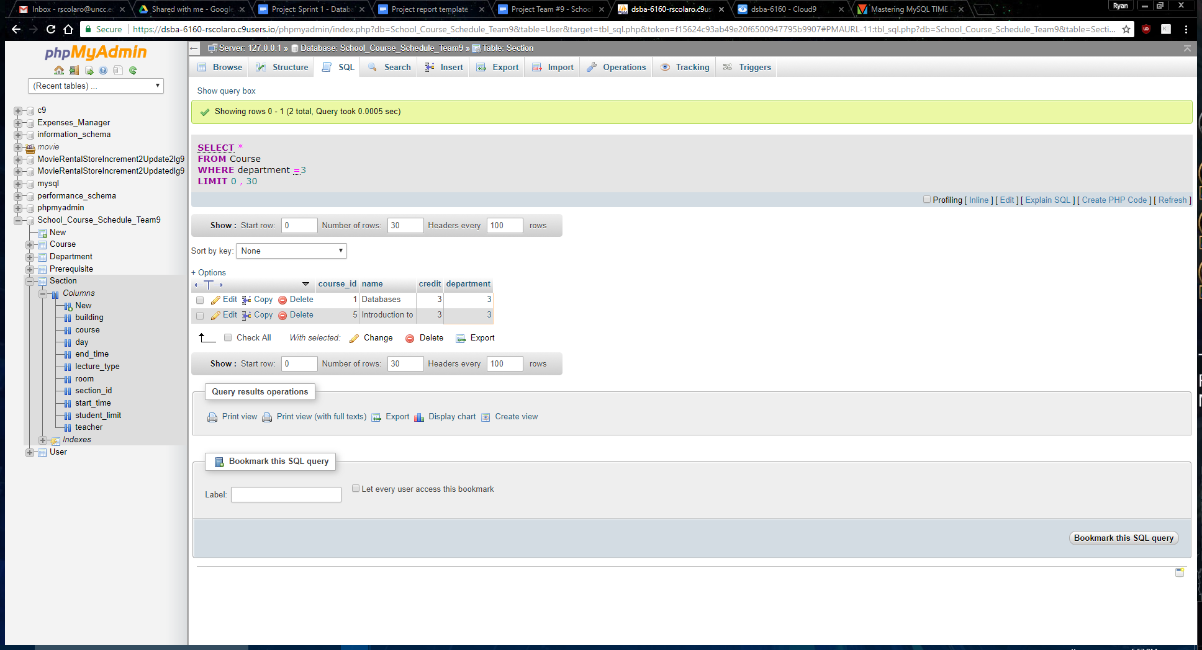

Get all prerequisite courses for databases class.

SELECT c.name AS 'Course', GROUP_CONCAT(c2.name) AS 'Prerequisite'

FROM Prerequisite AS p

INNER JOIN Course AS c on p.course = c.course_id

INNER JOIN Course AS c2 on p.prerequisite_course = c2.course_id

WHERE c.name = 'Databases'

GROUP BY c.name

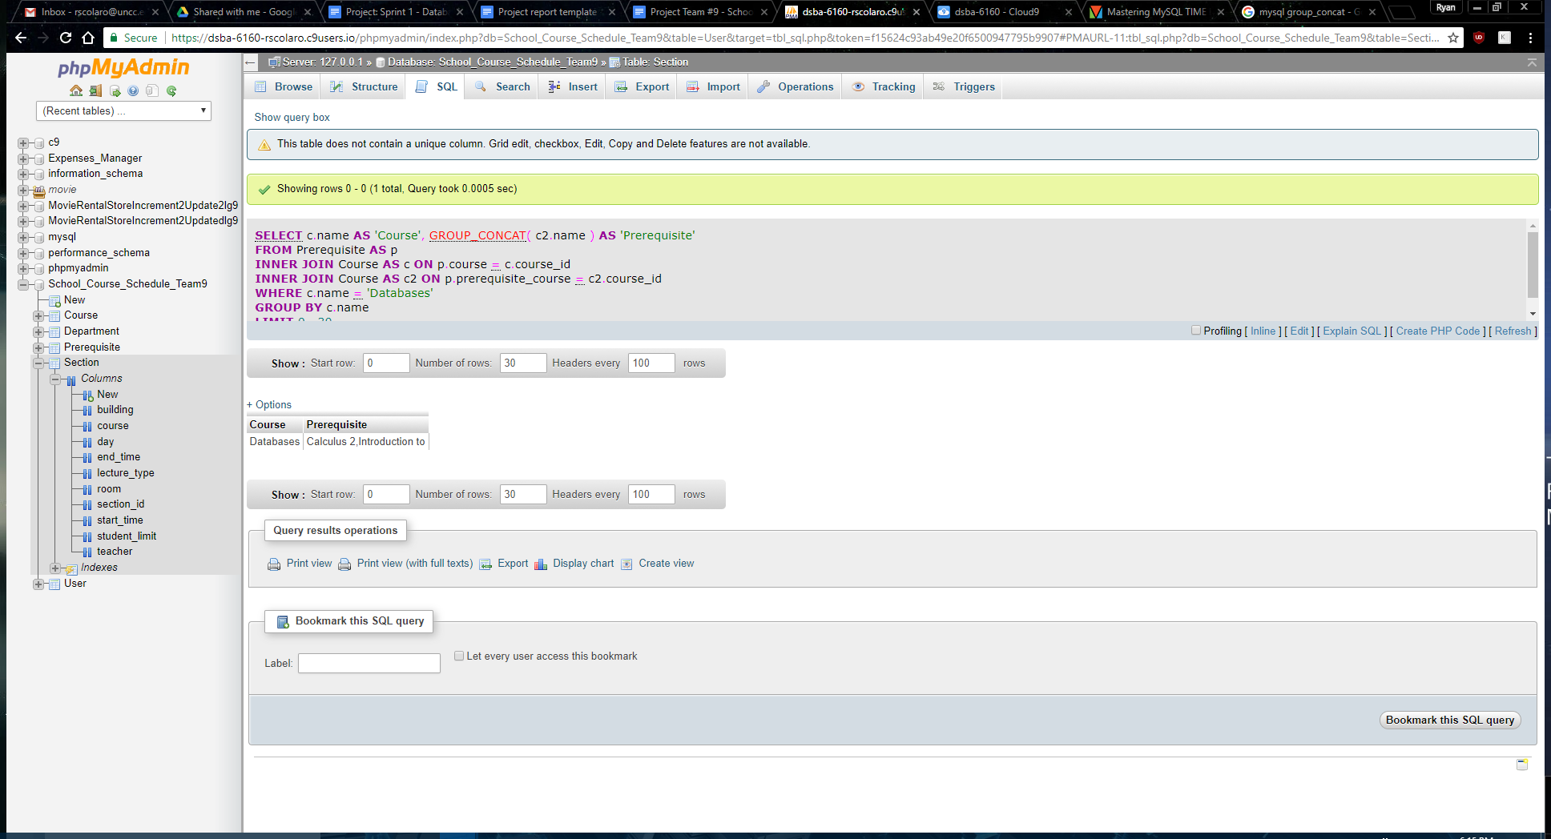

Get all sections of Introduction to Java.

SELECT *

FROM Section

Where course = 5

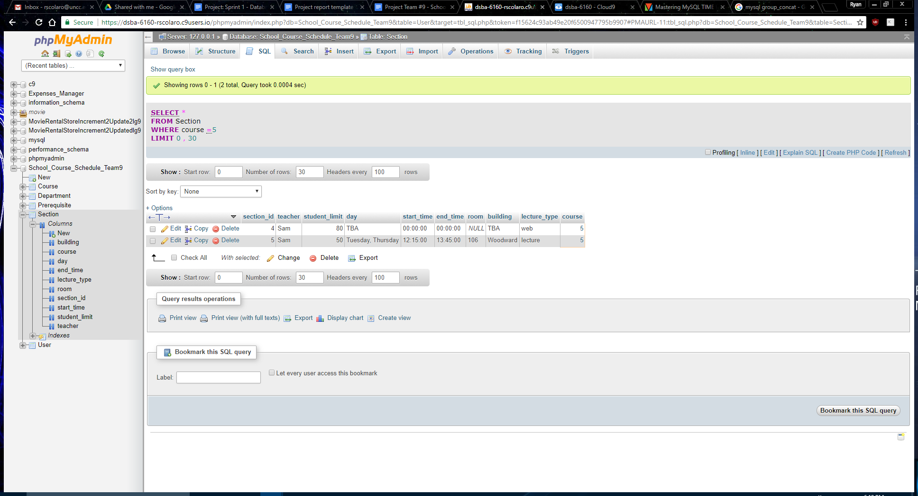

SPRINT 2

## ***REQUIREMENTS***

|  |  |
| --- | --- |
| **Story ID** | **Story description** |
| US1 | As an admin I want to register/login a new account so that I can have access to all features.  Details: As Admin is the one who add the departments and courses , delete the departments and courses, we should make sure that the admin is Authenticated person. |
| US2 | As an admin, I want to add a new department so that new courses can be added in that department.  Refactoring: Adding additional information such as department acronym. |
| US3 | As an admin, I want to add a new course with different sections so that students can enroll into the newly added course sections.  Details: Adding additional information about each course such as course code and description. |
| US4 | As an admin I want to create sections for a course so that students can enroll for the sections.  Details: Refactoring the existing course section information so that it better matches the structure of a section. This will require a lot of information about the things that a section depends on such as location, time slot, and teacher. |
| US5 | As a student I want to enroll for a course section so that I can take classes.  Details: In order for a student to register for a course section information about their previous courses taken and current course section schedule is needed. |

## ***CONCEPTUAL DESIGN***

Entity: **Admin**

Attributes:

username

password

name [composite]

first_name

last_name

Entity: **Department**

Attributes:

name

abbreviated_name

description

Entity: **Course**

Attributes:

name

course_number

credits

description

Entity: **Prerequisite**

Attributes:

course

prerequisite

Entity: **Section**

Attributes:

section_num

section_limit

year

Entity: **Semester**

Attributes:

season

Entity: **Building**

Attributes:

name

Entity: **Room**

Attributes:

number

capacity

Entity: **Lecture_Type**

Attributes:

type

Entity: **Lecture_Time**

Attributes:

start_time

end_time

Entity: **Lecture_Day**

Attributes:

day

Entity: **Teacher**

Attributes:

teacher_id

name [composite]

first_name

last_name

Entity: **Student**

Attributes:

student_id

name [composite]

first_name

last_name

Entity: **Transcript**

Attributes:

transcript_id

Relationship: **Department** has **Course**

Cardinality: Many to Many

Participation:

Department has total participation

Course has total participation

**Assumptions: Each Department will have at least one course and each course should be assigned to at least one department**

Relationship: **Course** has **Prerequisite**

Cardinality: Many to Many

Participation:

Course has partial participation

Prerequisite has total participation

Relationship: **Course** has **Section**

Cardinality: One to Many

Participation:

Course has partial participation

Section has total participation

Relationship: **Section** has **Semester**

Cardinality: Many to One

Participation:

Section has partial participation

Semester has total participation

Relationship: **Section** has **Room**

Cardinality: Many to One

Participation:

Section has partial participation

Room has partial participation

Relationship: **Building** has **Room**

Cardinality: One to Many

Participation:

Building has total participation

Room has total participation

Relationship: **Section** has **Lecture_Type**

Cardinality: Many to One

Participation:

Section has total participation

Lecture_Type has total participation

Relationship: **Section** has **Lecture_Time**

Cardinality: Many to Many

Participation:

Section has total participation

Lecture_Time has total participation

Relationship: **Section** has **Lecture_Day**

Cardinality: Many to Many

Participation:

Section has partial participation

Lecture_Day has partial participation

Relationship: **Section** has **Teacher**

Cardinality: Many to One

Participation:

Section has total participation

Teacher has partial participation

Relationship: **Section** has **Student**

Cardinality: Many to Many

Participation:

Section has partial participation

Student has partial participation

Relationship: **Student** has **Transcript**

Cardinality: One to One

Participation:

Student has total participation

Transcript has total participation

Relationship: **Transcript** has **Course**

Cardinality: Many to Many

Participation:

Transcript has total participation

Course has partial participation

***LOGICAL DESIGN***

Table: **Admin**

Columns:

username

password

first_name

last_name

Table: **Department**

Columns:

abbreviated_name

name

description

Table: **Course**

Columns:

course_id

name

course_number

credits

description

Table: **DepartmentCourse**

Columns:

course [foreign key; references **course_id** of **Course**]

department [foreign key; references **abbreviated_name** of

**Department**]

Table: **Prerequisite**

Columns:

course [foreign key; references **id** of **Course**]

prerequisite [foreign key; references **id** of **Course**]

Table: **Semester**

Columns:

season

Table: **Teacher**

Columns:

teacher_id

first_name

last_name

Table: **Section**

Columns:

section_id

section_num

section_limit

year

teacher [foreign key; references **teacher_id** of **Teacher**]

course [foreign key; references **course_id** of **Course**]

semester [foreign key; references **season** of **Semester**]

room [foreign key; references **room_id** of **Room**]

lecture_type [foreign key; references **type** of **Lecture_Type**]

*Justification: A generated id column is used to avoid having a*

*multi-column foreign key.*

Table: **SectionDayTime**

Columns:

section [foreign key; references **section_id** of **Section**]

time [foreign key; references **lecture_time_id** of **Lecture_Time**]

day [foreign key; references **day** of **Lecture_Day**]

Table: **Building**

Columns:

name

Table: **Room**

Columns:

room_id

number

capacity

building [foreign key; references **name** of **Building**]

*Justification: A generated id column is used to avoid having a multi-column foreign key.*

Table: **Lecture_Type**

Columns:

type

Table: **Lecture_Time**

Columns:

lecture_time_id

start_time

End_time

*Justification: A generated id column is used to avoid having a multi-column foreign key.*

Table: **Lecture_Day**

Columns:

day

Table: **Student**

Columns:

student_id

first_name

last_name

Table: **StudentSection**

Columns:

student [foreign key; references **student_id** of **Student**]

section [foreign key; references **section_id** of **Section**]

Table: **Transcript**

Columns:

transcript_id

student [foreign key; references **student_id** of **Student**]

Table: **TranscriptCourse**

Columns:

transcript [foreign key; references **transcript_id** of **Transcript**]

course [foreign key; references **course_id** of **Course**]

***Stored Procedures , Views and Triggers***

***Views:***

**View:** CourseInDepartment

Goal: This view contains all of the courses in every department. A user will be able to specify a department in the where clause to see only courses in a specific department. This is usually the first step when a student registers for a class.

**View:** SectionInformation

Goal: This view contains all of the information about every section. A user can use the where clause to specify sections of a specific class. This is usually the second step when a student registers for a class.

**View**: PrerequisiteRequirements

Goal: This view contains all courses that have pre-requisite course requirements and lists them with their respective pre-requisite courses

**Stored Procedures:**

**Stored procedure**: adddepartment

**Parameters**: departmentCode IN , departmentName IN, departmentDescription IN

**Goa**l: This stored procedure is for adding the Department, Admin is the only one who can add the department and details respective to that department

**Stored procedure**: addCourse

**Parameters**: courseNumbercode IN , courseName IN, courseDescription IN,credits IN

**Goa**l: This stored procedure is for adding the Course, Admin is the only one who can add the Course and details respective to that course.

**Stored procedure**: addCoursetoDepartment

**Parameters**: courseId IN , departmentCode IN

**Goa**l: This stored procedure is for adding the Course to a Department, Admin is the only one who can add the Course to a particular department, a Course can be added to any number of departments.

**Stored procedure**: studentRegistration

**Parameters**: firstName IN , lastname IN, student_id OUT

**Goa**l: This stored procedure is for students who are willing to get their student id . once the registration is done, student will get a unique student id using which student can enroll for classes.

**Stored procedure**: teacherRegistration

**Parameters**: firstName IN , lastname IN,teacher_id OUT

**Goa**l: This stored procedure is for Teacher Registration, only after registration, the admin can add the teacher to a section using the unique id which the teacher gets after completing the registration process.

**Stored procedure**: addSectiontoCourse

**Parameters**: sectionNumber IN , sectionLimit IN,year IN,teacher_id IN,courseId IN,semester IN,room_id IN,lecture_type IN

**Goa**l: This stored procedure is for adding a section to the any of the available course , only admin can do this as he is the only one authenticated to do so. Students can enroll in these sections.

**Stored procedure**: studentEnrollsIntoSection

**Parameters**: student_id IN ,section_id IN

**Goa**l: This stored procedure is for Student enrollment in sections , only after registration student can enroll for classes using his unique id. , here Student can only enroll for section if the section slots are available also if the section the student is trying to enroll conflicts in both day and time with the classes they already enrolled , then they will not be allowed to enroll for the section

**Stored procedure**: timingscheck

**Parameters**: student_id IN ,time_id IN

**Goa**l: This stored procedure is for checking the time conflicts if any , when student tries to enroll for a new section , the timings of new sections will be checked with the timings of all the sections he already enrolled , if any conflicts occurs a conflict code will be send which prevents student from enrolling in to that new section

**Stored procedure**: check_Sectionlimit

**Parameters**: seclimit IN ,room IN, limitresult OUT

**Goa**l: This stored procedure is for checking whether the student limit of a particular section is less than or equal to room capacity , if student limit is more than room capacity then error message will be thrown and section will not get added to the course.

**Stored procedure**: sectionSchedule

**Parameters**: sectionId IN ,daySlot IN, timeSlot OUT

**Goa**l: This stored procedure is for checking the time slot and the day that is being allocated to a section is free or not , if the slots are free then the section will be alloted this slots else error message will be thrown asking the admin to choose different slots for the section.

**Stored procedure**: teacherSection

**Parameters**: teacher_id IN ,section_id IN

**Goa**l: This stored procedure is for teacher handling a new sections , only after registration teacher can handle the classes using his unique id. if the section the Teacher is trying to handle conflicts in both day and time with the classes they are already handling , they will not be allowed to handle the section

**Stored procedure**: teachertimingscheck

**Parameters**: teacher_id IN ,time_id IN

**Goa**l: This stored procedure is for checking the time conflicts if any , when teacher tries to handle a new section , the timings of new sections will be checked with the timings of all the sections he already enrolled , if any conflicts occurs , then a conflict code will be send which prevents that teacher from handling that new section

***Triggers:***

**Trigger:** AFTER INSERT ON StudentSection

Goal: This Trigger is for Increasing the Student Count of particular section.Right after a student enrolls for a section the trigger gets executed and increases the student count of the enrolled section in the section table by 1. This trigger makes sure that student_count will not exceed the student_limit for that section , after the limit is reached if a student tries to enroll for the section , he can’t do so as the slots for the section are already filled up.

**Sprint 3**

## ***REQUIREMENTS***

|  |  |
| --- | --- |
| **Story ID** | **Story description** |
| US1 | As an admin I want to register/login a new account so that I can have access to all features.  Details: As Admin is the one who add the departments and courses , delete the departments and courses, we should make sure that the admin is Authenticated person. |
| US2 | As an admin, I want to add a new department so that new courses can be added in that department.  Refactoring: Adding additional information such as department acronym. |
| US3 | As an admin, I want to add a new course with different sections so that students can enroll into the newly added course sections.  Details: Adding additional information about each course such as course code and description. |
| US4 | As an admin I want to create sections for a course so that students can enroll for the sections.  Details: Refactoring the existing course section information so that it better matches the structure of a section. This will require a lot of information about the things that a section depends on such as location, time slot, and teacher. |
| US5 | As a student I want to enroll for a course section so that I can take classes.  Details: In order for a student to register for a course section information about their previous courses taken and current course section schedule is needed. |
| US 6 | As a student I want to make sure I don’t have any courses conflicting by time and date.  Details: Will require information about each student’s course schedule and checking course sections against that schedule. |
| US 7 | As a teacher I want to make sure I don’t teach any conflicting courses by time, date, and room.  Details: Will require information about all each teacher’s schedule and checking it against all the scheduled course sections. |

## ***CONCEPTUAL DESIGN***

Entity: **Admin**

Attributes:

username

password

name [composite]

first_name

last_name

Entity: **Department**

Attributes:

name

abbreviated_name

description

Entity: **Course**

Attributes:

name

course_number

credits

description

Entity: **Prerequisite**

Attributes:

course

prerequisite

Entity: **Section**

Attributes:

section_num

section_limit

year

Entity: **Semester**

Attributes:

season

Entity: **Building**

Attributes:

name

Entity: **Room**

Attributes:

number

capacity

Entity: **Lecture_Type**

Attributes:

type

Entity: **Lecture_Time**

Attributes:

start_time

end_time

Entity: **Lecture_Day**

Attributes:

day

Entity: **Teacher**

Attributes:

teacher_id

name [composite]

first_name

last_name

Entity: **Student**

Attributes:

student_id

name [composite]

first_name

last_name

Entity: **Transcript**

Attributes:

transcript_id

Relationship: **Department** has **Course**

Cardinality: Many to Many

Participation:

Department has total participation

Course has total participation

**Assumptions: Each Department will have at least one course and each course should be assigned to at least one department**

Relationship: **Course** has **Prerequisite**

Cardinality: Many to Many

Participation:

Course has partial participation

Prerequisite has total participation

Relationship: **Course** has **Section**

Cardinality: One to Many

Participation:

Course has partial participation

Section has total participation

Relationship: **Section** has **Semester**

Cardinality: Many to One

Participation:

Section has total participation

Semester has total participation

Relationship: **Section** has **Room**

Cardinality: Many to One

Participation:

Section has partial participation

Room has partial participation

Relationship: **Building** has **Room**

Cardinality: One to Many

Participation:

Building has total participation

Room has total participation

Relationship: **Section** has **Lecture_Type**

Cardinality: Many to One

Participation:

Section has total participation

Lecture_Type has partial participation

Relationship: **Section** has **Lecture_Time**

Cardinality: Many to Many

Participation:

Section has partial participation

Lecture_Time has partial participation

Relationship: **Section** has **Lecture_Day**

Cardinality: Many to Many

Participation:

Section has partial participation

Lecture_Day has partial participation

Relationship: **Section** has **Student**

Cardinality: Many to Many

Participation:

Section has partial participation

Student has partial participation

Relationship: **Student** has **Transcript**

Cardinality: One to One

Participation:

Student has total participation

Transcript has total participation

Relationship: **Transcript** has **Course**

Cardinality: Many to Many

Participation:

Transcript has total participation

Course has partial participation

Relationship: **Student** has **Section**

Cardinality: Many to Many

Participation:

Student has total participation

Section has partial participation

Relationship: **Teacher** has **Section**

Cardinality: Many to Many

Participation:

Teacher has partial participation

Section has partial participation

***LOGICAL DESIGN***

Table: **Admin**

Columns:

username

password

first_name

last_name

Highest normalization level: 4NF

Index:

Index 1: non-clustered

Columns: last_name, first_name

Justification: We typically get the details of the admin using last_name,but in some cases last_names can be same so combination of last_name and first_name will be a good index.Also if someone forgets their username, the best way to search their username is by using the last name and first name of the person.

Table: **Department**

Columns:

abbreviated_name

name

description

Highest normalization level: 4NF

Index:

Index 1: non-clustered

Columns: name

Justification: In most cases everyone searches the department by its name as it is the easy and efficient way to get the information, also not everyone knows the abbreviated name of the department.

Table: **Course**

Columns:

course_id

name

course_number

credits

description

Highest normalization level: 4NF

Indexes:

Index 1: non-clustered

Columns: name

Justification: People generally search for a course by its name as very few people are aware of the course numbers , so using it as an index will allow for faster searching.

Table: **DepartmentCourse**

Columns:

course [foreign key; references **course_id** of **Course**]

department [foreign key; references **department_id** of

**Department**]

Highest normalization level: 4NF

Indexes:

Index 1: non-clustered

Columns: department

Justification: Department will be a good index , generally when someone wants to know all the courses in a department, searching by department gives efficient results.

Table: **Prerequisite**

Columns:

course [foreign key; references **course_id** of **Course**]

prerequisite [foreign key; references **course_id** of **Course**]

Highest normalization level: 4NF

Indexes:

Index 1: non clustered

Columns: course

Justification: In most cases prerequisites for a course will be searched based on course , so Course will serve as a good index.

Table: **Semester**

Columns:

season

Highest normalization level: 4NF

Indexes:

Index 1: clustered

Columns: season

Justification: season will be a good index as everyone is aware of only the semester names, and every one uses the semester name to get the result they want.

Table: **Teacher**

Columns:

teacher_id

first_name

last_name

Highest normalization level: 4NF

Indexes:

Index 1: non-clustered

Columns: first_name, last_name

Justification: teacher_id is the primary key, but most teachers will be searched using first_name and last_name so they make up the covering index.

Table: **Section**

Columns:

section_id

section_num

section_limit

year

course [foreign key; references **course_id** of **Course**]

semester [foreign key; references **semester_id** of **Semester**]

room [foreign key; references **room_id** of **Room**]

lecture_type [foreign key; references **lecture_type_id** of **Lecture_Type**]

*Justification: A generated id column is used to avoid having a*

*multi-column foreign key.*

Highest normalization level: 4NF

Indexes:

Index 1: non-clustered

Columns: course, section_num

Justification: Usually a section will be linked to a course , searching by course and section_num will get the accurate details for a section , so combination of course and section_num will be a good index.

Table: **SectionDayTime**

Columns:

section [foreign key; references **section_id** of **Section**]

time [foreign key; references **lecture_time_id** of **Lecture_Time**]

day [foreign key; references **lecture_day_id** of **Lecture_Day**]

Highest normalization level: 4NF

Indexes:

Index 1: non-clustered

Columns: section

Justification: details for a particular section will be searched based on section_id, details will be efficient if searched using section_id , so section_id will be a good index.

Table: **Building**

Columns:

name

Highest normalization level: 4NF

Indexes:

Index 1: clustered

Columns: name

Justification: Any building will be remembered by its name , so using its name as an index will be effective and searching will be efficient.

Table: **Room**

Columns:

room_id

number

capacity

building [foreign key; references **building_id** of **Building**]

*Justification: A generated id column is used to avoid having a multi-column foreign key.*

Highest normalization level: 4NF

Indexes:

Index 1: non-clustered

Columns: number

Justification: Room number is the best option to find a room and its details, so using room number as an index will make searching easy.

Table: **Lecture_Type**

Columns:

type

Highest normalization level: 4NF

Indexes:

Index 1: clustered

Columns: type

Justification: lecture_type is best way to find all the lectures with lectures of the required type , so it will be good index.

Table: **Lecture_Time**

Columns:

lecture_time_id

start_time

end_time

*Justification: A generated id column is used to avoid having a multi-column foreign key.*

Highest normalization level: 4NF

Indexes:

Index 1: non-clustered

Columns: start_time, end_time

Justification: Combination of start_time and end_time will be a good index as it is easy way to search.

Table: **Lecture_Day**

Columns:

day

Highest normalization level: 4NF

Indexes:

Index 1: non-clustered

Columns: day

Justification: Using day names is easy to remember and search, so the day column will be a good index.

Table: **Student**

Columns:

student_id

first_name

last_name

Highest normalization level: 4NF

Indexes:

Index 1: non-clustered

Columns: first_name, last_name

Justification: Student_id is the primary key, but most students will be searched using first_name and last_name, so both of those attributes make up the index.

Table: **Transcript**

Columns:

transcript_id

student [foreign key; references **student_id** of **Student**]

Highest normalization level: 4NF

Indexes:

Index 1: non-clustered

Columns: student

Justification: We will be searching through transcripts using student as each student has 1 transcript and we will be searching the table in regards to the particular student we are addressing, so student serves as good index.

Table: **TranscriptCourse**

Columns:

transcript [foreign key; references **transcript_id** of **Transcript**]

course [foreign key; references **course_id** of **Course**]

Highest normalization level: 4NF

Indexes:

Index 1: non-clustered

Columns: course

Justification: The course attribute in this table is what we will be primarily use to get the transcript for that particular course, so course is the index.

Table: **StudentSection**

Columns:

student [foreign key; references **student_id** of **Student**]

section [foreign key; references **section_id** of **Section**]

Highest normalization level: 4NF

Indexes:

Index 1: non-clustered

Columns: student

Justification: We will be searching through this table primarily using the student key to get the details of the sections he enrolled so far, so having student as an index will be efficient.

Table: **TeacherSection**

Columns:

teacher [foreign key; references **teacher_id** of **Teacher**]

section [foreign key; references **section_id** of **Section**]

Highest normalization level: 4NF

Indexes:

Index 1: non-clustered

Columns: teacher

Justification: We will be searching through this table primarily using the teacher key to get the details of the sections the teacher is handling, so teacher should be the index.